The recipe for you
Who do you look like?
Your DNA is the recipe for you - and that recipe comes from your mother and your father. Half of your genes, which is located in you DNA, comes from your mother, and half from your father.
DNA stands for Deoxyribose Nucleic Acid. It’s parts of the DNA that makes up your genes, and your genes decide who you are.
In a way, your genes are like a software. They contain a massive set of codes for, how your body works and develops.
Many of the visible characteristics you can inherit, you probably already know of - for example:
- The color of your eye
- Haircolor
- If your hairline rounded or arrow-shaped
The visible characteristics are signs, that something is inherited from parent to child. But the visible characters are only a fraction of what is inherited.
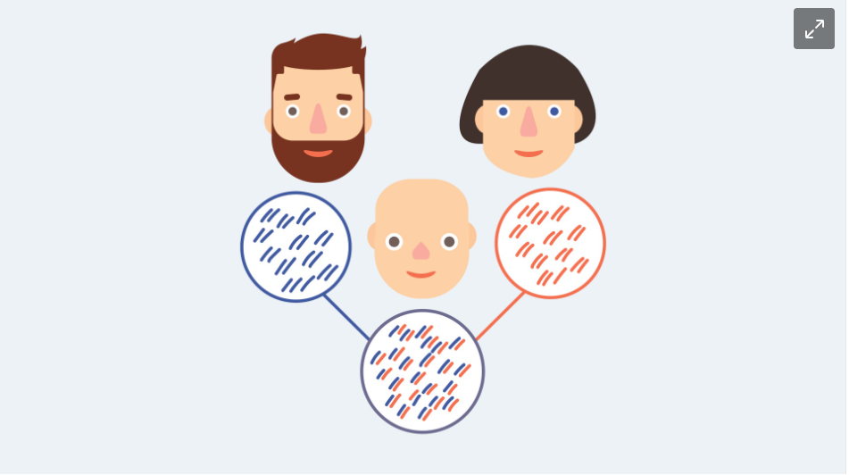
Half of your genes is from your mother. The other half is from your father.
Cells
All living organisms is made of cells. Humans consists of at least 10.000.000.000.000 cells. Every single cell in the body are formed from a single cell - the fertilized egg cell.
During development in the uterus the cell divides and the cells specializes. Not all cells have the same function, but in most living organisms, they are built in much the same way. They have a nucleus, containing the DNA and other organelles that makes the cell function. These look much alike in every cell.
All living cells contain DNA. In many single cell organisms, such as bacteria, the DNA is not in a nucleus.
Both animal cells and plant cells are eukaryotic, meaning they have a nucleus, where the DNA is stored.
Eukaryote means “real nucleus”, referring to the fact that they have a nucleus, not like prokaryotes, which are cells with no nucleus.
Chromosomes
Chromosomes is made from DNA, the DNA which is found in the nucleus. The chromosomes as we know them, in the X-shape, can be seen when the DNA-string is curled up.
Humans have 46 chromosomes - or 23 pairs. The pairs contain 2 each - one from your father and one from your mother.
The genes are part of the chromosomes. Scientists have actually mapped out all the genes on all the 46 chromosomes, and can tell with accuracy where different genes are. For example, we know where 2 of the most important genes coding for eye color is, which is on chromosome 15 and 19. That doesn’t mean it’s simple though - no less than 16 genes in total can influence what color your eyes are.
The DNA molecule
The DNA string is the shape of a double spiral. It is double-stranded, and it looks a bit like a ladder. The strands makes up the sides of the ladder. Each strand consists of an alternate carbohydrate molecule and a phosphate molecule.
Between the two strands you can find 4 bases: A, T, C and G. It is the order in which these 4 bases are located, that decides, how the gene looks.
Adenine (A) is always paired with Thymine (T). Cytosine (C) is always paired with Guanine (G). The base pairs are located between the two strands, making it double stranded.
The DNA molecules in each of our cells, contains in total 3,2 billion base pairs.
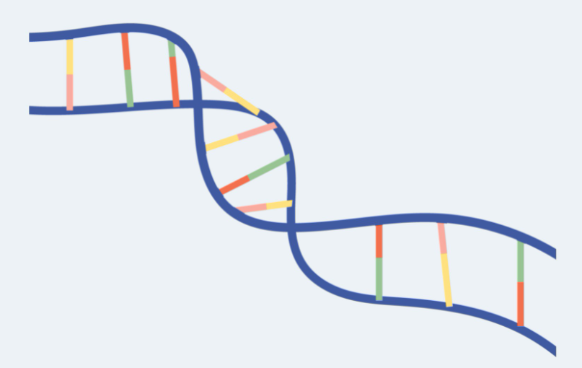
A DNA molecule
The DNA molecule is double stranden and acts like a spiral.

